CSC 352 / 452: Database Programming
Oracle jdeveloper

8. Oracle JDeveloper

This class shows you how to use Oracle JDeveloper to access an Oracle database from a java application. You will run queries against tables, insert data into a table, and update a table.

Oracle JDeveloper is a free integrated development environment that simplifies the development of Java-based applications and user interfaces with support for the full development life cycle.

You may download Oracle JDeveloper (free) software from:

https://ipdapp.cdm.depaul.edu/jdev/ , or

http://www.oracle.com/technology/software/products/jdev/index.html.

8.1 JDBC

JDBC (Java Database Connectivity) is an API specification developed by Sun Microsystems that defines a uniform interface for accessing various relational databases. JDBC is a core part of the Java platform and is included in the standard JDK distribution.

(An application programming interface (API) is a source code interface that an operating system, library or service provides to support requests made by computer programs.)

The primary function of the JDBC API is to provide a means for the developer to issue SQL statements and process the results in a consistent, database-independent manner.

The JDBC API uses a Driver Manager and database-specific drivers to provide transparent connectivity to heterogeneous databases. The JDBC driver manager ensures that the correct driver is used to access each data source. The Driver Manager is capable of supporting multiple concurrent drivers connected to multiple heterogeneous databases.

Java Application
JDBC API
JDBC Driver Manager

JDBC Driver
JDBC Driver
JDBC Driver

Oracle
SQL Server
……

8.2 Installing Oracle JDeveloper

Oracle JDeveloper does not require an installer. To install Oracle JDeveloper, you will need an unzip tool.

Unzip jdevstudio.zip into a directory (folder) of your choice (for example: c:\)

Unzipping sqldeveloper.zip causes a directory named jdevstudio to be created under the C directory. It also causes many files and folders to be placed in and under that directory.

To start Oracle JDeveloper, go to the c:\jdevstudio directory, and then double-click jdeveloper.exe.

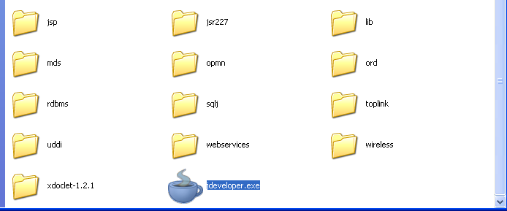

8.3 Setting up the Environment

Before you can start to use JDBC in Oracle JDeveloper, you must perform certain setup tasks.

1) Have started Oracle JDeveloper by double-clicking c:\jdevstudio\jdeveloper.exe.

If you receive a message asking if you want to migrate from a previous version, click No. Close the Tip of the Day window.

2) In Oracle JDeveloper, select File | New. The New Gallery displays.

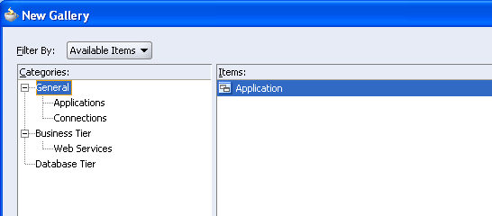

3) In the Categories pane accept the default General, and from the Items pane, the default Application.
Click OK.

4) In the Create Application dialog, type myApp. Ensure that the Application Template dropdown is set to No Template [All Technologies]. Click OK.

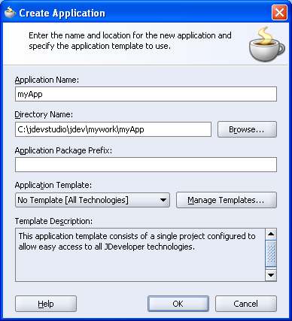

Note that the application template automatically provides you with a single project configured to allow easy access to all Oracle JDeveloper technologies.

5) In the Create Project dialog, enter myProject as the Project name, and then click OK.

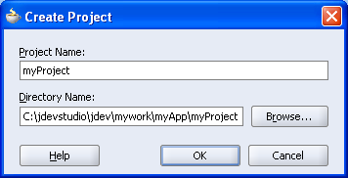

6) The new application and project are displayed in the Application Navigator. (If the Application Navigator is not displayed, choose View | Application Navigator.)

Select the application name, and choose File | Save All.

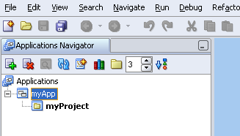

7) Double-click the project name in the Navigator to invoke the project properties dialog. Find and select Libraries, and then click Add Library.

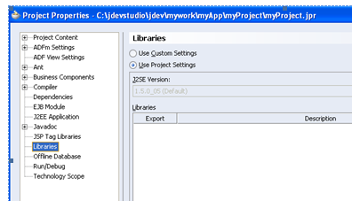

8) A list of available libraries is displayed. Scroll through the list to find Oracle JDBC. Select it, and then click OK.

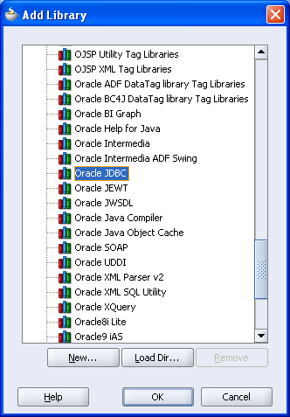

9) Click OK.

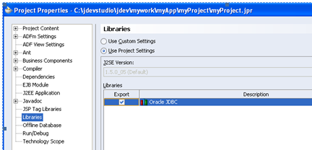

8.4 Creating a Java Class

1) Select your project in the Navigator. Right-click and select New … from the short-cut menu.

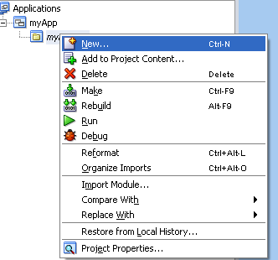

2) In the New Gallery, retain General as the default category, and select Java Class from the items pane. Click OK.
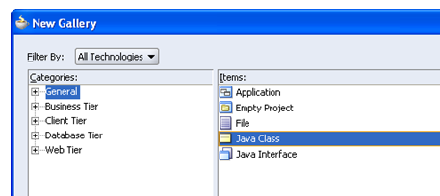

3) In the Create Class dialog, type the name myDBProc. Note the Optional Attributes box: leave the Public and Generate Default Constructor checkboxes checked, and in addition, check the Generate Main Method checkbox. Click OK.

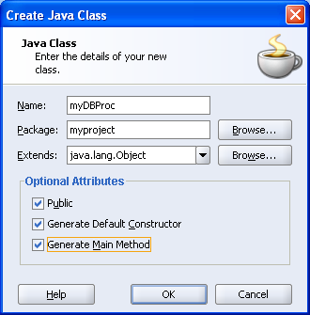

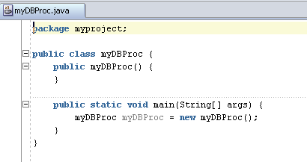

----------------------------------------------------------------------
package myproject;

public class myDBProc {
public myDBProc() {
}

public static void main(String[] args) {
myDBProc myDBProc = new myDBProc();
}
}
----------------------------------------------------------------------

Note an instance of the myDBProc class is created for you as part of the main method. This is where all the methods of the class are to be defined.

4) You need to import the following packages to be able to use the JDBC classes:

java.sql.*
oracle.jdbc.driver.*

In the Code Editor, on a new line under the generated package statement, start to type the following statement:

import java.sql.*;

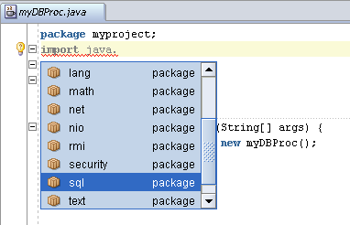

Note that the code insight feature of Oracle JDeveloper prompts you as you type by offering you a list of possible options to complete the statement.

5) Double-click on an option in the list to add it to your statement.

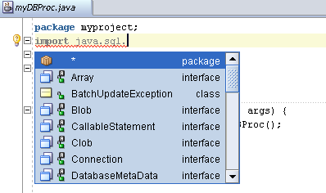

6) Type the import statement as follows, using the Code Insight feature if you wish.

import oracle.jdbc.driver.*;

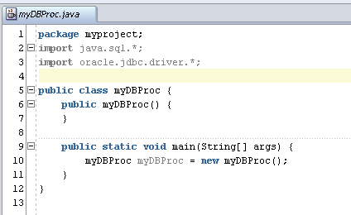

7) In the Code Editor, add the following code to your public static void main statement:

throws Exception

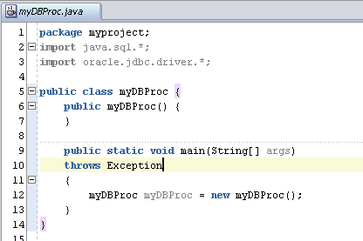

This removes the requirement to catch any exceptions thrown in this method. In general you should catch the exceptions thrown and handle them appropriately.

----------------------------------------------------------------------
package myproject;
import java.sql.*;
import oracle.jdbc.driver.*;

public class myDBProc {
public myDBProc() {
}

public static void main(String[] args)
throws Exception
{
myDBProc myDBProc = new myDBProc();
}
}
----------------------------------------------------------------------

8) Add a trace message “Hello World” in the main method.

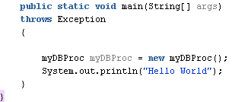

----------------------------------------------------------------------
package myproject;
import java.sql.*;
import oracle.jdbc.driver.*;

public class myDBProc {
public myDBProc() {
}

public static void main(String[] args)
throws Exception
{
myDBProc myDBProc = new myDBProc();
System.out.println("Hello World");
}
}
----------------------------------------------------------------------

9) To run your program, right-click in the Code Editor and choose Run from the context menu.

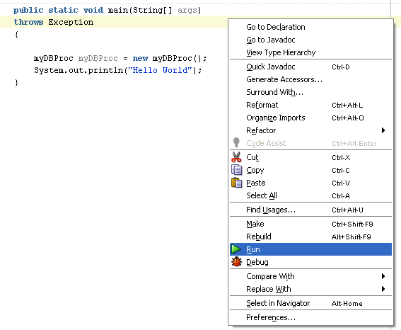

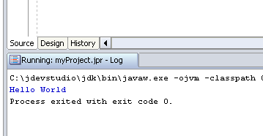

The message “Hello World” displays in the Log window at the bottom of the screen.

8.5 Getting Connected

In order to connect to the database, JDBC drivers must first register themselves with the driver manager. This example uses the register.Driver() method of the java.sql.Drivermanger. You then call the getConnection() method to create the connection.

When you create a Connection object, it is an auto-commit mode, meaning that each SQL statement is committed after it is executed. However you can disable auto-commit, and group the statements, which must then be explicitly terminated by calling commit() or rollback(). This example shows you how to disable auto-commit.

1) Declare a connection instance in your myDBProc class definition.

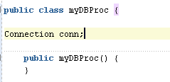

2) Create a method called initialize to hold the connection code.

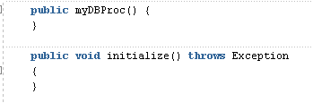

3) Register the driver in the initialize method.

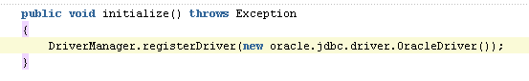
4) To connect to the database, add the connect statement as follows:

conn = DriverManager.getConnection
("jdbc:oracle:thin:@cdmoracledb.cti.depaul.edu:1521:def", "your_user_name", "your_password");

Replace your_user_name and your_password with appropriate values for your account information.

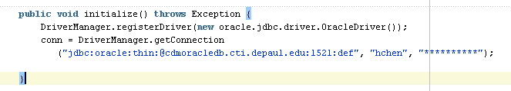

5) Disable auto-commit for this connection.
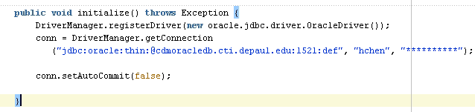

6) Add a line of code to check that you have managed to successfully connect to the database.

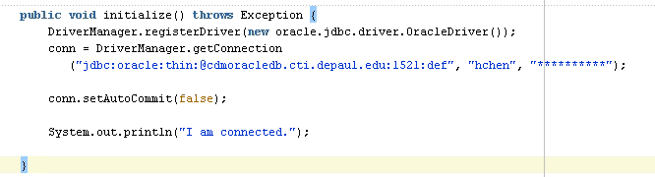

7) In the main method, invoke the initialize method.

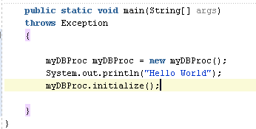

8) Create a method called terminate to hold the closing code.

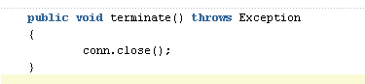

9) In the main method, invoke the terminate method.

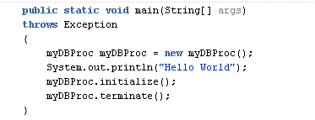

10) Run your program. The message “I am connected” displays in the Log window at the bottom of the screen.

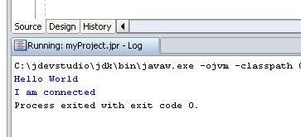

----------------------------------------------------------------------
package myproject;
import java.sql.*;
import oracle.jdbc.driver.*;

public class myDBProc {

Connection conn;

public myDBProc() {
}

public void initialize() throws Exception {
DriverManager.registerDriver(new oracle.jdbc.driver.OracleDriver());
conn = DriverManager.getConnection
("jdbc:oracle:thin:@cdmoracledb.cti.depaul.edu:1521:def", "your_username", "your_password");

conn.setAutoCommit(false);

System.out.println("I am connected.");

}

public void terminate() throws Exception {
conn.close();
}

public static void main(String[] args)
throws Exception
{
myDBProc myDBProc = new myDBProc();
System.out.println("Hello World");
myDBProc.initialize();
myDBProc.terminate();
}
}
----------------------------------------------------------------------

8.6 Executing a Query

Once you have registered the driver and connected to the database, you are ready to run queries against the data.

1) Declare a statement instance in you myDBProc class definition. To do this, create a new line below your connection declaration, and type in the following code:

Statement stmt;

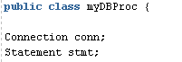

2) Create a method called listDept to hold the department query code.

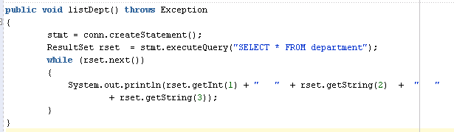

Note that the rset.getXXX methods need the required column number of the result row as a parameter.

3) In the main method, invoke the listDept method. Update the terminate method.

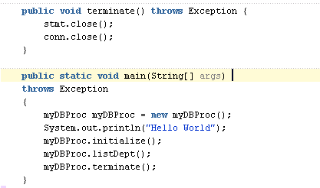

4) Run the program.

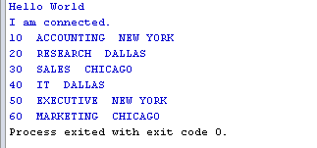

----------------------------------------------------------------------
package myproject;
import java.sql.*;
import oracle.jdbc.driver.*;

public class myDBProc {

Connection conn;
Statement stmt;

public myDBProc() {
}

public void listDept() throws Exception {
stmt = conn.createStatement();
ResultSet rset = stmt.executeQuery("SELECT * FROM department");
while (rset.next())
{
System.out.println(rset.getInt(1) + " " + rset.getString(2) + " " + rset.getString(3));
}
}
public void initialize() throws Exception {
DriverManager.registerDriver(new oracle.jdbc.driver.OracleDriver());
conn = DriverManager.getConnection
("jdbc:oracle:thin:@cdmoracledb.cti.depaul.edu:1521:def", "your_username", "your_password");

conn.setAutoCommit(false);

System.out.println("I am connected.");

}

public void terminate() throws Exception {
stmt.close();
conn.close();
}

public static void main(String[] args)
throws Exception
{
myDBProc myDBProc = new myDBProc();
System.out.println("Hello World");
myDBProc.initialize();
myDBProc.listDept();
myDBProc.terminate();
}
}
----------------------------------------------------------------------

5) Declare a prepared statement instance in you myDBProc class definition.

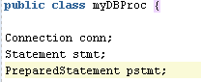

6) Update the listDept method as follows.

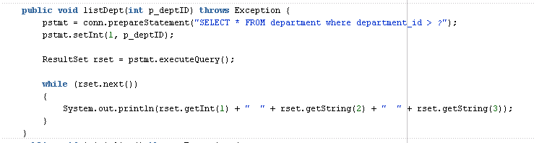

7) Update the terminate method.

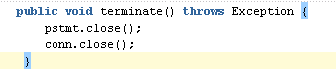

8) Run the program.

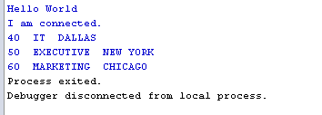

----------------------------------------------------------------------
package myproject;
import java.sql.*;
import oracle.jdbc.driver.*;

public class myDBProc {

Connection conn;
Statement stmt;
PreparedStatement pstmt;

public myDBProc() {
}

public void listDept(int p_deptID) throws Exception {
pstmt = conn.prepareStatement("SELECT * FROM department where department_id > ?");
pstmt.setInt(1, p_deptID);

ResultSet rset = pstmt.executeQuery();

while (rset.next())
{
System.out.println(rset.getInt(1) + " " + rset.getString(2) + " " + rset.getString(3));
}
}
public void initialize() throws Exception {
DriverManager.registerDriver(new oracle.jdbc.driver.OracleDriver());
conn = DriverManager.getConnection
("jdbc:oracle:thin:@cdmoracledb.cti.depaul.edu:1521:def", "your_username", "your_password");

conn.setAutoCommit(false);

System.out.println("I am connected.");

}

public void terminate() throws Exception {
pstmt.close();
conn.close();

}

public static void main(String[] args)
throws Exception
{
myDBProc myDBProc = new myDBProc();
System.out.println("Hello World");
myDBProc.initialize();
myDBProc.listDept(30);
myDBProc.terminate();
}
}
----------------------------------------------------------------------

9) How do you get JDeveloper to prompt you for the input value?

(a) Type the import statement as follows, using the Code Insight feature if you wish.

import java.util.Scanner;

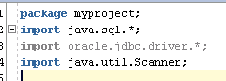

(b) Add the following statements to the procedure.

Scanner sc = new Scanner(System.in);

System.out.println("Please enter department_id:");
myDeptID = Integer.parseInt(sc.next());

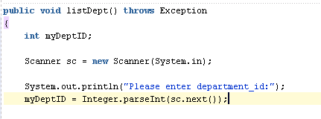

----------------------------------------------------------------------
package myproject;
import java.sql.*;
import oracle.jdbc.driver.*;
import java.util.Scanner;

public class myDBProc {

Connection conn;
Statement stmt;
PreparedStatement pstmt;

public myDBProc() {
}

public void listDept() throws Exception {

int v_deptID;

Scanner sc = new Scanner(System.in);

System.out.println("Please enter department_id:");
v_deptID = Integer.parseInt(sc.next());

pstmt = conn.prepareStatement("SELECT * FROM department where department_id > ?");
pstmt.setInt(1, v_deptID);

ResultSet rset = pstmt.executeQuery();

while (rset.next())
{
System.out.println(rset.getInt(1) + " " + rset.getString(2) + " " + rset.getString(3));
}
}
public void initialize() throws Exception {
DriverManager.registerDriver(new oracle.jdbc.driver.OracleDriver());
conn = DriverManager.getConnection
("jdbc:oracle:thin:@cdmoracledb.cti.depaul.edu:1521:def", "your_username", "your_password");

conn.setAutoCommit(false);

System.out.println("I am connected.");

}

public void terminate() throws Exception {
pstmt.close();
conn.close();
}

public static void main(String[] args)
throws Exception
{
myDBProc myDBProc = new myDBProc();
System.out.println("Hello World");
myDBProc.initialize();
myDBProc.listDept();
myDBProc.terminate();
}
}

----------------------------------------------------------------------

(c) Go into the project properties and edit the current Run/Debug Configuration.

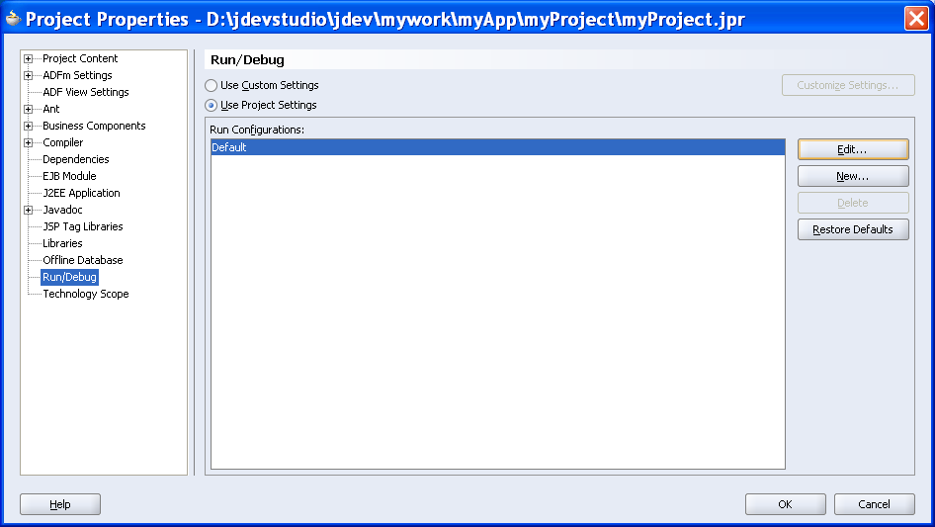

(d) Under the tools settings node you'll see that the last item allows you to specify "Allow Program Input"
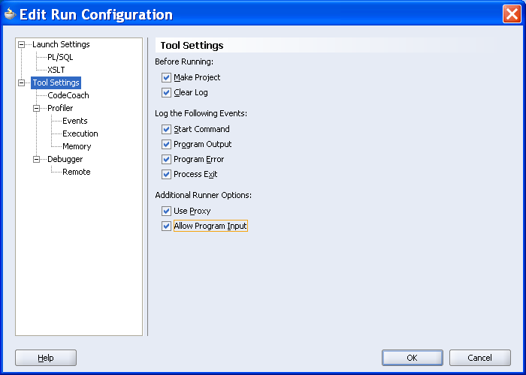

(e) Run the program.

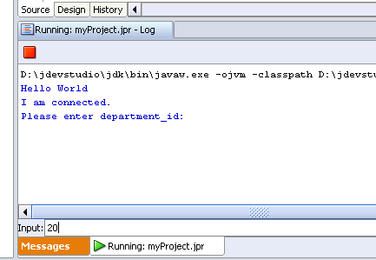

Hit Enter key after typing 20.
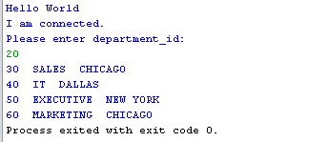

8.7 Inserting a Row into a Table

Once you have registered the driver and connected to the database, you are ready to insert a new row into the dept table. Because you disabled auto-commit in a previous step, you must explicitly commit the insert to the database. In addition, you add some exception-handling to check SQL errors. If it finds any, it reports the error and terminates the program. This checks that a department cannot be inserted twice. Finally, you confirm that the insert has taken place by running a query against the dept table.

1) Create a method called insertDept to hold the insert code.

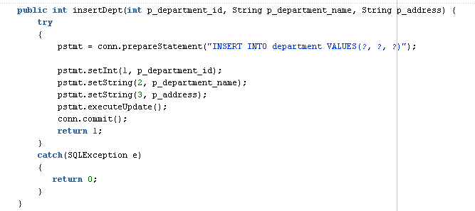

2) In the main method, invoke the insertDept method, and check the error return.

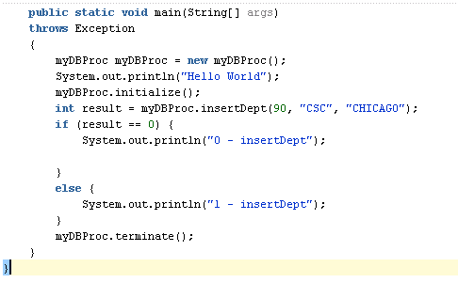

3) Run the program.

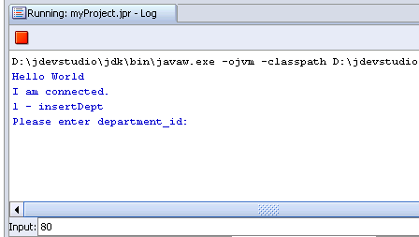

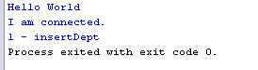

----------------------------------------------------------------------
package myproject;
import java.sql.*;
import oracle.jdbc.driver.*;
import java.util.Scanner;

public class myDBProc {

Connection conn;
Statement stmt;
PreparedStatement pstmt;

public myDBProc() {
}

public int insertDept(int p_department_id, String p_department_name, String p_address) {
try
{
pstmt = conn.prepareStatement("INSERT INTO department VALUES(?, ?, ?)");

pstmt.setInt(1, p_department_id);
pstmt.setString(2, p_department_name);
pstmt.setString(3, p_address);
pstmt.executeUpdate();
conn.commit();
return 1;
}
catch(SQLException e)
{
return 0;
}
}

public void initialize() throws Exception {
DriverManager.registerDriver(new oracle.jdbc.driver.OracleDriver());
conn = DriverManager.getConnection
("jdbc:oracle:thin:@cdmoracledb.cti.depaul.edu:1521:def", "your_username", "your_password");

conn.setAutoCommit(false);

System.out.println("I am connected.");

}

public void terminate() throws Exception {
pstmt.close();
conn.close();
}

public static void main(String[] args)
throws Exception
{
myDBProc myDBProc = new myDBProc();
System.out.println("Hello World");
myDBProc.initialize();
int result = myDBProc.insertDept(90, "CSC", "CHICAGO");
if (result == 0) {
System.out.println("0 - insertDept");

}
else {
System.out.println("1 - insertDept");
}
myDBProc.terminate();
}
}
----------------------------------------------------------------------

8.8 Updating Data in a Table

1) Create a method called updateDept to hold the update code.

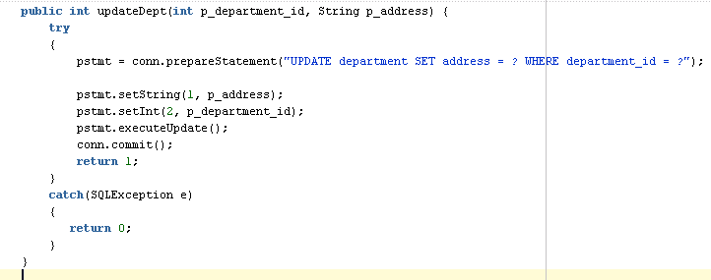

2) Update the main method.

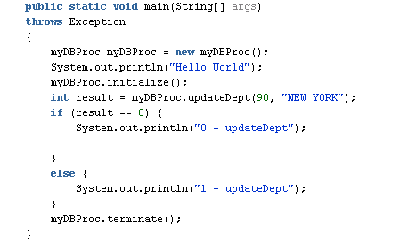

3) Run the program.

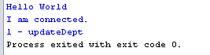

----------------------------------------------------------------------

package myproject;
import java.sql.*;
import oracle.jdbc.driver.*;
import java.util.Scanner;

public class myDBProc {

Connection conn;
Statement stmt;
PreparedStatement pstmt;

public myDBProc() {
}

public int updateDept(int p_department_id, String p_address) {
try
{
pstmt = conn.prepareStatement("UPDATE department SET address = ? WHERE department_id = ?");

pstmt.setString(1, p_address);
pstmt.setInt(2, p_department_id);
pstmt.executeUpdate();
conn.commit();
return 1;
}
catch(SQLException e)
{
return 0;
}
}

public void initialize() throws Exception {
DriverManager.registerDriver(new oracle.jdbc.driver.OracleDriver());
conn = DriverManager.getConnection
("jdbc:oracle:thin:@cdmoracledb.cti.depaul.edu:1521:def", "your_username", "your_password");

conn.setAutoCommit(false);

System.out.println("I am connected.");

}

public void terminate() throws Exception {
pstmt.close();
conn.close();
}

public static void main(String[] args)
throws Exception
{
myDBProc myDBProc = new myDBProc();
System.out.println("Hello World");
myDBProc.initialize();
int result = myDBProc.updateDept(90, "NEW YORK");
if (result == 0) {
System.out.println("0 - updateDept");

}
else {
System.out.println("1 - updateDept");
}
myDBProc.terminate();
}
}
----------------------------------------------------------------------

8.9 Calling Oracle Procedures

1) Create a stored procedure as follow,

CREATE OR REPLACE PROCEDURE
my_proc (p_1 NUMBER, p_2 OUT NUMBER, p_3 IN OUT VARCHAR2)
AS
BEGIN
p_2 := p_1 + 100;
p_3 := p_3 || ' DePaul University';

EXCEPTION
WHEN OTHERS THEN
p_3 := 'N/A';
END;

2) Declare a callableStatement statement instance in you myDBProc class definition.

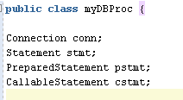

3) Create a method called callStoredProc as follows.

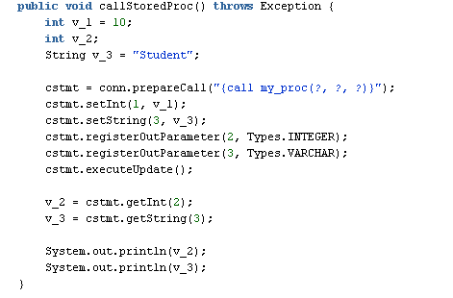

4) Update the main method and the terminate method.

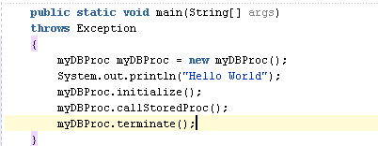

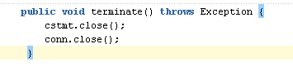

5) Run the program.

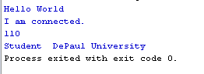

----------------------------------------------------------------------
package myproject;
import java.sql.*;
import oracle.jdbc.driver.*;
import java.util.Scanner;

public class myDBProc {

Connection conn;
Statement stmt;
PreparedStatement pstmt;
CallableStatement cstmt;

public myDBProc() {
}

public void callStoredProc() throws Exception {
int v_1 = 10;
int v_2;
String v_3 = "Student";

cstmt = conn.prepareCall("{call my_proc(?, ?, ?)}");
cstmt.setInt(1, v_1);
cstmt.setString(3, v_3);
cstmt.registerOutParameter(2, Types.INTEGER);
cstmt.registerOutParameter(3, Types.VARCHAR);
cstmt.executeUpdate();

v_2 = cstmt.getInt(2);
v_3 = cstmt.getString(3);

System.out.println(v_2);
System.out.println(v_3);
}

public void initialize() throws Exception {
DriverManager.registerDriver(new oracle.jdbc.driver.OracleDriver());
conn = DriverManager.getConnection
("jdbc:oracle:thin:@cdmoracledb.cti.depaul.edu:1521:def", "your_username", "your_password");

conn.setAutoCommit(false);

System.out.println("I am connected.");

}

public void terminate() throws Exception {
cstmt.close();
conn.close();
}

public static void main(String[] args)
throws Exception
{
myDBProc myDBProc = new myDBProc();
System.out.println("Hello World");
myDBProc.initialize();
myDBProc.callStoredProc();
myDBProc.terminate();
}
}
----------------------------------------------------------------------

8.10 Calling Oracle Functions

1) Create a function as follow,

CREATE OR REPLACE FUNCTION find_area
(p_length IN NUMBER DEFAULT 0, p_width IN NUMBER DEFAULT 0) RETURN NUMBER
AS
v_area NUMBER;
BEGIN
v_area := p_length * p_width;
RETURN v_area;
END;

2) Create a method called callStoredFun to hold your codes.

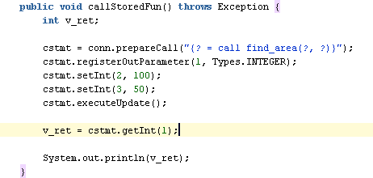

3) Update the main method.

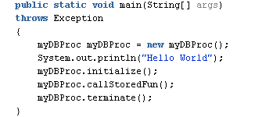

4) Run the program.

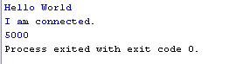

----------------------------------------------------------------------
package myproject;
import java.sql.*;
import oracle.jdbc.driver.*;
import java.util.Scanner;

public class myDBProc {

Connection conn;
Statement stmt;
PreparedStatement pstmt;
CallableStatement cstmt;

public myDBProc() {
}

public void callStoredFun() throws Exception {
int v_ret;

cstmt = conn.prepareCall("{? = call find_area(?, ?)}");
cstmt.registerOutParameter(1, Types.INTEGER);
cstmt.setInt(2, 100);
cstmt.setInt(3, 50);
cstmt.executeUpdate();

v_ret = cstmt.getInt(1);

System.out.println(v_ret);
}

public void initialize() throws Exception {
DriverManager.registerDriver(new oracle.jdbc.driver.OracleDriver());
conn = DriverManager.getConnection
("jdbc:oracle:thin:@cdmoracledb.cti.depaul.edu:1521:def", "your_username", "your_password");

conn.setAutoCommit(false);

System.out.println("I am connected.");

}

public void terminate() throws Exception {
cstmt.close();
conn.close();
}

public static void main(String[] args)
throws Exception
{
myDBProc myDBProc = new myDBProc();
System.out.println("Hello World");
myDBProc.initialize();
myDBProc.callStoredFun();
myDBProc.terminate();
}
}
----------------------------------------------------------------------

